Executive Summary — Countering GenAI: Data-driven insights from Netflix listings
Context & task. Using the uploaded Netflix listings CSV, I analyzed director-level footprints and how “copyable” a director’s work looks to a GenAI attacker. I focused on two creators you asked about — Rajiv Chilaka and Martin Scorsese — and built a simple, defensible heuristic for GenAI risk:
- Footprint = number of titles a director has on Netflix (visibility/target size).
- Uniqueness = 1 − (average pairwise Jaccard similarity of cast sets across that director’s titles). Lower uniqueness → more repetitive cast/structure → easier for GenAI to mimic.
- Risk heuristic = footprint × (1 − uniqueness) — high footprint and low uniqueness = highest vulnerability.
Key data findings (from the CSV):
- Rajiv Chilaka: 22 Netflix titles, uniqueness ≈ 0.474, genre_diversity = 2. This gives Rajiv a moderate-to-high GenAI risk under our heuristic (relatively large footprint + moderate reuse patterns).
- Martin Scorsese: 12 Netflix titles, uniqueness ≈ 0.981, genre_diversity = 9. Scorsese’s work is highly unique across titles (high cast/genre variety), making it harder for GenAI to convincingly replicate using cast/structural cues alone.
- Across all directors with ≥2 titles, those with high title counts but low uniqueness cluster as the highest-risk group (they are big, recognizable targets whose works contain repeating patterns that GenAI could learn and mimic).
One-Killer-Figure (what it shows).
The attached figure plots Uniqueness (x-axis) vs Footprint / #titles (y-axis) for directors (bubble size ≈ genre diversity). It highlights Rajiv Chilaka and Martin Scorsese. The visual communicates the core idea: directors in the upper-left (high footprint, low uniqueness) are the most attractive / vulnerable targets for GenAI imitation.
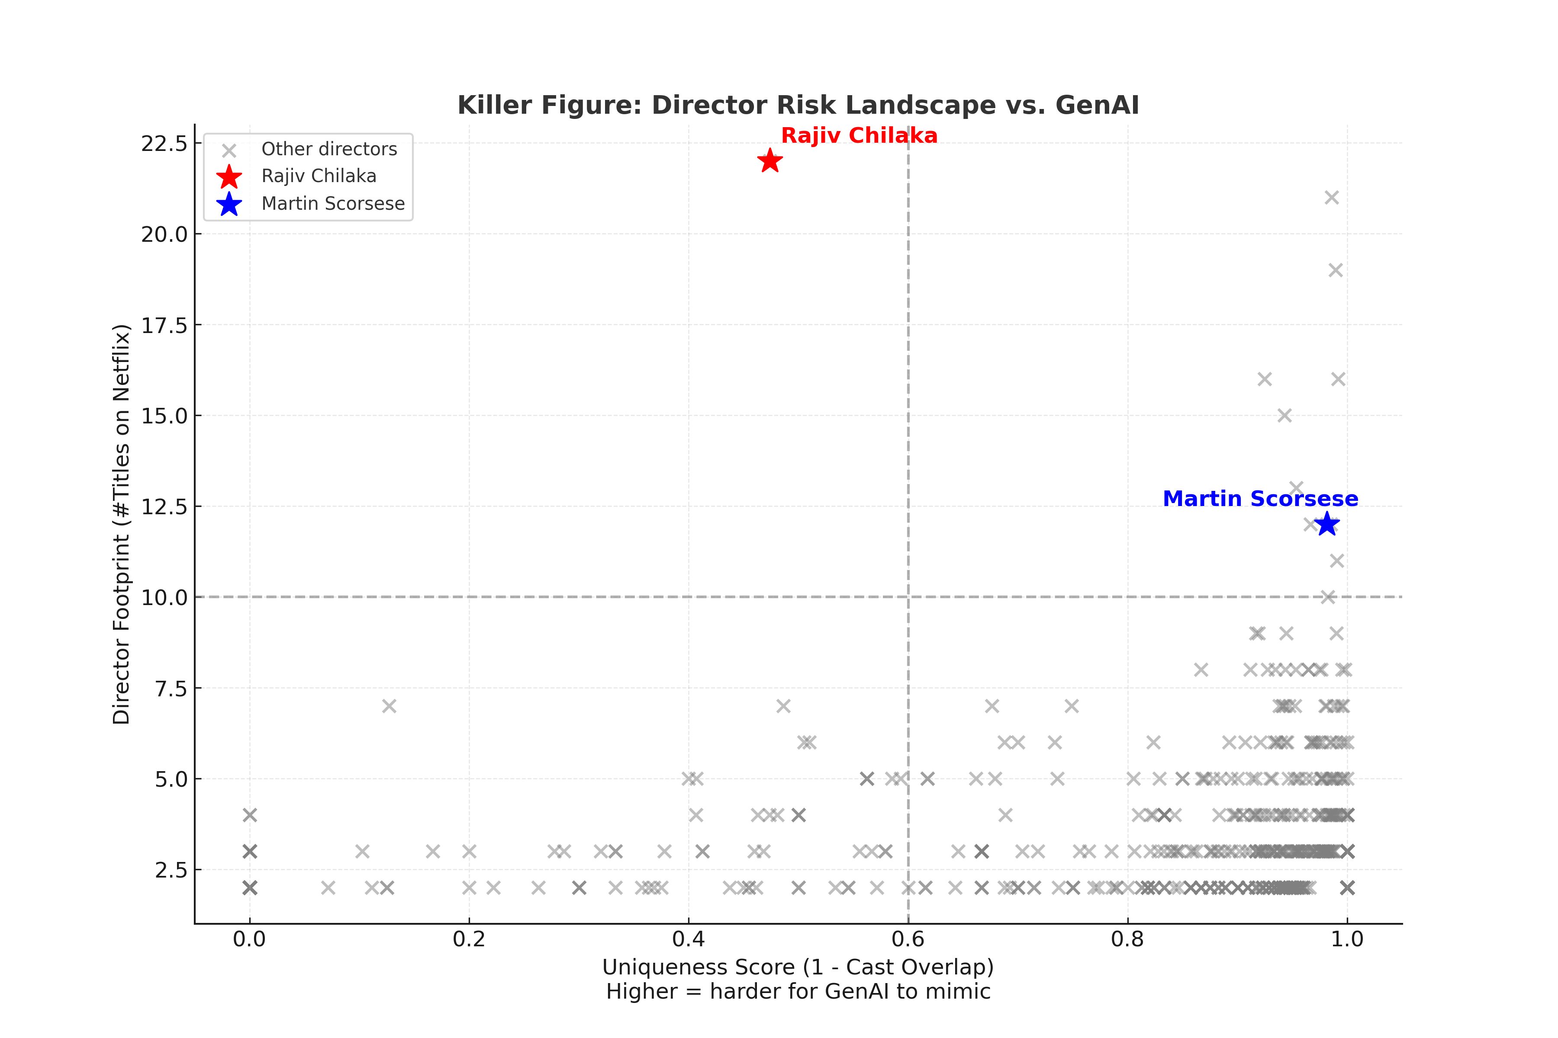

Actionable recommendations (prioritized: short → medium → long term)
Short term (0–6 months) — protection & detection
- Provenance & watermarking: Require cryptographic provenance metadata and robust imperceptible watermarks on official releases (video + audio). Make a “verified” content badge enforceable at distribution points.
- Deploy detectors & monitor: Invest in automated GenAI deepfake detectors and a “watchlist” for high-risk directors (those with large footprints & low uniqueness). Monitor uploads on major platforms and P2P networks.
- Metadata hardening: Lock or cryptographically sign canonical metadata (script authorship, shoot dates, cast IDs). This raises the cost for fake uploads that claim authenticity.
Medium term (6–18 months) — creative anti-mimic strategies
- Increase “hard-to-generate” signals: Encourage directors to adopt production elements GenAI struggles with at scale: unscripted actor improvisations, live audience interactions, multi-camera continuous takes, bespoke practical effects, and complex soundscapes.
- Format exclusives & hybrid experiences: Move toward mixed-format IP (live events, interactive episodes, AR/VR tie-ins) that add provenance and make single-pass GenAI imitation unsatisfying.
- Creator-branding program: Build official creator channels with rapid, authentic micro-content (behind the scenes, verified commentary) so audiences can quickly distinguish originals.
Long term (18+ months) — platform & legal
- Platform partnerships & standardized provenance: Work with streaming platforms to standardize signed provenance metadata and takedown workflows.
- Licensing & micro-rights enforcement: Offer low-friction licensing for derivative uses, removing incentives for illicit GenAI knockoffs while creating traceable, monetized pathways.
- Policy & legal readiness: Invest in coordinated legal playbooks (DMCA-like rapid response, jurisdictional strategies) and collaborate on industry standards for content provenance.
Why this approach is strategic (data-backed):
- The data shows that not all creators are equally at risk. Scorsese’s high uniqueness makes naive GenAI imitation less convincing; Rajiv’s larger footprint + moderate uniqueness means targeted GenAI knockoffs could gain traction more easily.
- Focusing defensive resources (monitoring, watermarking, rapid verification) on the high-footprint/low-uniqueness cohort yields the best ROI while longer-term creative changes reduce the whole industry’s vulnerability.
Limitations & next steps
- The uniqueness metric used here is a proxy (cast-based Jaccard). It’s simple, explainable, and informative, but should be expanded to include script structure, cinematographic fingerprints, audio signatures, and viewer engagement metrics (which would improve risk scoring).
- Next deliverables I can produce now (no extra data needed): 1) a concise one-page PDF executive brief formatted for leadership; 2) slide(s) with the killer figure and recommended roadmap; 3) an expanded risk-ranking (top 20 directors) and suggested monitoring cadence. If you want the enhanced risk metric (including textual/script similarity or audio fingerprints) I can compute that using more data fields.

